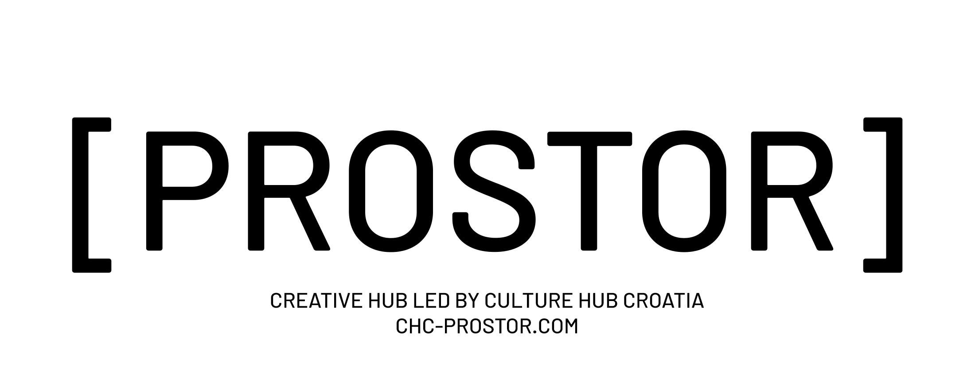
Residency Application Form

Please send the application together with your CV and portfolio to info@culturehubcroatia.hr stating RESIDENCY APPLICATION as subject line.

NAME AND SURNAME:
DATE OF BIRTH:
NATIONALITY:
PLACE OF RESIDENCE:

Preferred duration of the residency (minimum one week, maximum 3 months):

Please indicate your preferred period of stay:

Please shortly describe your plan for the residency. What will you be working on? (max. 200 words)

What do you expect to gain by participating in your residency? Please shortly describe your motivations and expectations for the residency. (max. 200 words)

